Introduction

Specifications

System Chipset | Intel 82440 BX chipset.
CPU | Intel Pentium II processors, support 233/266/300/333 (Ex. Clk 66MHz) MHz.  300/350/400/ 450/ 500 (Ex. Clk 100MHz) MHz
Memory | Expandable to 768MB (3 banks) with three 168-pin DIMM socket {support 3.3 V EDO (66MHz only) / SDRAM (66MHz/ 100MHz)}.
I/O | Winbond 83977, two high speed 16550 compatible serial ports, one Multi-Mode.  Parallel Port support SPP/EPP/ECP standard mode.  Two onboard PCI IDE Ports (32-bit data transfer). LS-120/ ZIP FDD, IrDA/ ASK IR/ Consumer IR.  Dual USB ports  Support two 360/720KB/1.2/1.44/2.88MB floppy disk devices.  One PS/2 Mouse port.
BIOS | Award System BIOS installed in socket (Flash and PnP).
Expansion slots |  | One AGP slot, five PCI Master Slots and two 16-bit ISA Slots.
Voltage |  | Auto 1.8V-3.5V
Dimension |  | 4-layer PCB, size (300mm x 190mm).
Others |  | Support BIOS setting CPU type (Jumper-less), CPU Auto Temperature Sensor & Music Alarm, voltage monitor and CPU Fan monitor, Bus Master/ Ultra DMA/33, ACPI, AGP Bus, Keyboard Power On, PS/2 Mouse Power On, Modem Ring On, LAN wake up, Debug sensor on board.

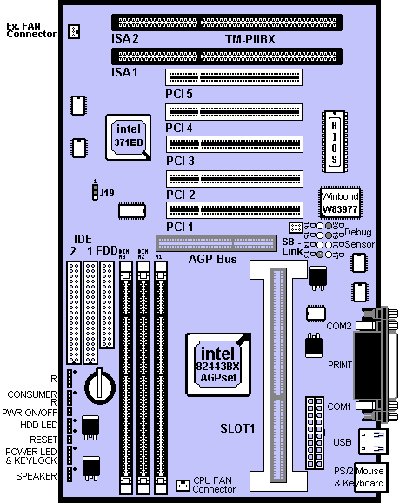
Setup Guide

Layout Diagram

Smart Debug On Board
When the CPU, DRAM, Cache RAM, FDD or VGA card have not been properly installed, user can isolate those basic problems through the Debug Sensor LED and instructions from the manual. To Professional system engineers or maintenance engineers, the Debug Sensor can work as an 80 Port Debug Sensor Card.

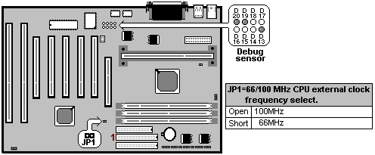

Error code |  | Display | Message | Solution
 | C1 | None | Can’t detect DRAM | 1. Reinstall or replace the SDRAM.  2. Reinstall or replace the BIOS.
 | C6 | None | Can’t detect DRAM | 1. Reinstall or replace the SDRAM.  2. Reinstall or replace the BIOS.
 | OD | None | Can’t detect VGA card | 1. Reinstall or replace the VGA card.  2. Replace the BIOS.
 | 4E | Yes | Can’t detect Floppy disk | 1. Replace the BIOS. (if no screen)  2. Enter the BIOS Setup menu to reset.  3. Check that the FDD cable and the power  connector are properly connected.  4. Reconnect the FDD cable or replace the FDD.
 | 61 | Yes | L2 cache problem | 1. Enter BIOS Setup to disable the external cache.

CPU Voltage and Frequencies

ROM PCI/ISA BIOS (2A69KTJ9)
CHIPSET FEATURE SETUP
AWARD SOFTWARE, INC
Auto Configuration | : Enabled | Auto Detect DIMM/ PCI Clk | : Enabled
EDO DRAM Speed Selection | : 60ns | CPU Speed | : Manual
EDO CASx# MA Wait State | : 2 | CPU Ratio | : X 2.5
EDO RASx# Wait State | : 2 | CPU Frequency | : 100 MHz
SDRAM RAS-to CAS Delay | : 3 | Spread Spectrum | : Disabled
SDRAM RAS Precharge Time | : 3 | CPU Warning Temperature | : Disabled
SDRAM CAS latency Time | : Auto | Current CPU Temperature | : 28℃/ 82℉
DRAM Data Integrity Mode | : Non-ECC | Current SYSFAN Speed | :4285 RPM
System BIOS Cacheable | : Enabled | Current CPUFAN Speed | :4000 RPM
Video BIOS Cacheable | : Enabled | Current Vin3 (V) | : 2.88V
Video RAM Cacheable | : Disabled
8 Bit I/O Recovery Time | : 1
16 Bit I/O Recovery Time | : 1
Memory Hole At 15M-16M | : Disabled
Passive Release | : Enabled | Esc : Quit ↑↓→← Selection : Item
Delayed Transaction | : Disabled | F1 : Help PU/PD/+/- : Modify
AGP Aperture Size (MB) | : 64 | F5 : Old Values (Shift) F2 : Color  F6 : Load BIOS Default  F7 : Load Setup Default
Dear Customers:
Thank you for your patronage of our products. The board you bought is a jumper-less mainboard. The ratio and frequency of the CPU shall be set in BIOS and the working voltage for the CPU shall be automatically detected. Please read carefully the following instructions:

1. Power on the installed system and press the "DEL" key to enter BIOS Setup. Select "Chipset Features Setup" and press <Enter>.

2. Select "CPU Speed" and press "PgUp" or "PgDn" to set the CPU ratio and frequency. The available options are Intel PII
233MHz (66X3.5), 266MHz (66X4), 300MHz (66X4.5), 333MHz (66X5), 366MHz (66X5.5), 400MHz(66X6), 433MHz(66X6.5), 466MHz(66X7), 500MHz(66X7.5).
250MHz(100X2.5), 300MHz(100X3), 350MHz(100X3.5), 400MHz(100X4), 450MHz(100X4.5), 500MHz(100X5), 550MHz(100X5.5), 600MHz(100X6) and "Manual".
To set the CPU manually, please note the following:

CPU Speed: "Manual" (you can manually set the CPU ratio and frequency)
CPU Ratios: x3.5, x4, x4.5, x5, x5.5, x6, x6.5, x7, x7.5
CPU Frequency: 66, 68, 75, 83, 100, 103, 112, 133Mhz

Several options are provided for the CPU external clock. You are recommended to restore to the default setting in case of instability when the external clock exceeds 66MHz.

NOTE: System failure may occur if the CPU frequency is set incorrectly. To solve this problem. Press the "Insert" key on the keyboard to clear the previously set frequency (i. c., restore the default frequency), and then reboot the system.

- Switch voltage is applied, making the temperature lower and voltage steadier.

- You don’t need to adjust Voltage in Pentium II mainboard. It will automatically send out one VID (Voltage Identification) to the mainboard power supply to ask for the voltage it needs.

- The CPU type default setting is Intel Pentium II 250MHz=100 MHz＊2.5.

Intel Pentium II CPU family
CPU | Ext. clk | Ratio | L1 cache | L2 cache | Package
Intel Pentium II – 450MHz | 100MHz | X4.5 | 32KB | 512KB | SECC 1
Intel Pentium II – 400MHz | 100MHz | X4 | 32KB | 512KB | SECC 1
Intel Pentium II – 350MHz | 100MHz | X3.5 | 32KB | 512KB | SECC 1/ 2
Intel Pentium II – 300MHz | 100MHz | X3 | 32KB | 512KB | SECC 1
Intel Pentium II – 333MHz | 66MHz | X5 | 32KB | 512KB | SECC 1
Intel Pentium II – 300MHz | 66MHz | X4.5 | 32KB | 512KB | SECC 1
Intel Pentium II – 266MHz | 66MHz | X4 | 32KB | 512KB | SECC 1
Intel Pentium II – 233MHz | 66MHz | X3.5 | 32KB | 512KB | SECC 1

EDO/ SDRAM Installation Procedures:
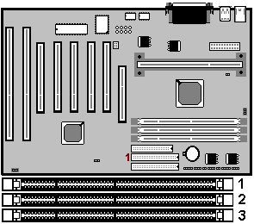
- A 168-pin DIMM can support up to 768MB 3.3V EDO (66MHz) / SDRAM (66MHz/ 100MHz).

- You are recommended to use SDRAMs. With SPD that are compliant with PC-100. This will enable BIOS to detect the SDRAM speed, thereby fully bring into play the efficiency of the SDRAM.
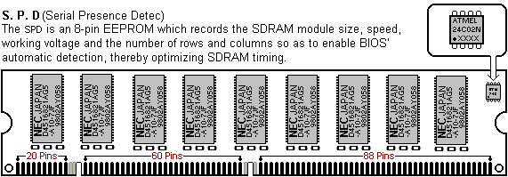
- To avoid compatibility and reliability problems, you are recommended to test the 168-pin SDRAMs before buying them since the PCB specifications differ.
- First, verify the working voltage of the EDO/ SDRAM module in either DIMM socket.

- P2BX only supports 3.3V EDO/ SDRAM module. The following illustration shows you the difference between 3.3V and 5V to ensure your correct selection of 3.3V DIMM module for using.

- You can set up the BIOS “Chipset Feature Setup” to the best working condition basing on the type of EDO/ SDRAM you are using.

- The BIOS DRAM default setting is 60 ns. Change the BIOS “Chipset Feature Setup” default setting to 50ns for better performance, if the chipset is marked 50ns.

- Change nothing if EDO RAM is used. BIOS automatically detect the RAM type.

- MEMO for Installing System:
⊕ Concerning memory setup, you can find how to from “Chipset Feature Setup” under BIOS setup. However, to avoid system unstable or system hang, user without engineering background is not suggested to change BIOS set up.
⊕ If system boot failure, please clean DIMM socket (with clean oil) or polish Gold-Finger of DRAM with soft eraser, and try again.

- The Dual Inline Memory Module (DIMM) must be 3.3 Volt and Unbuffered Synchronous DRAM (SDRAM) 8MB, 16MB, 32MB, 64MB, 128MB or 256MB. The following illustration shows the type of DIMM Module.
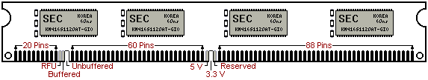
168-PIN SDRAM DIMM Notch Key Definitions

Other Jumper Settings
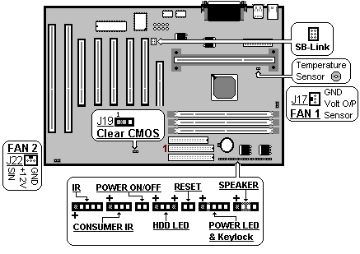
- Speaker: Connect to the system’s speaker for beeping.
- Keylock: Keyboard lock switch and Power LED connector.
- Reset: Short to restart system.
- HDD LED: LED ON when on board PCI IDE hard disk activates.
- POWER SW (FOR ATX POWER SUPPLY):
The button should be a momentary switch that is normally open. Pushing the ATX Power Switch will immediately change the system status. Before or during “POST”, you need to hold the button for four seconds in order to turn off the system.
- J19: Clear CMOS
Turn off the system and short pins 2-3 to clear CMOS. Then short pins 1-2 before turning it on.

J19
1-2 | Normal operation(Default).
2-3 | for clearing CMOS Data.
- CPU Cooler Fan connector
This is the connector for CPU cooler. Never use the jumper to short the connector. Serious damages caused this way will not be warrantied.
- Creative SB-Link
It is used to connect the AWE64 or other compatible sound cards so that they are made compatible with the ISA-compatible SB16 sound cards.

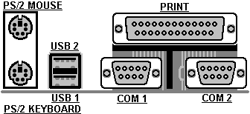

Note to BIOS Update

Do not update the BIOS if no abnormalities occur. However, if BIOS update is needed, consult your dealer first. Prior to updating your BIOS, you are recommended to save the original BIOS values.

1. Download the AWARD BIOS Flash Utility file (Awdflash.exe)

2. Download the BIOS file used by your mainboard(e.g., BXV110N.BIN)

3. Reboot your system (but do not run Himem.sys and Emm386.exe) to
execute the new BIOS program.

4. Execute these commands: Awdflash BXV110N.BIN

5. When this message displays: "Do you want to save BIOS (Y/N)?"
Type "N"

6. When this message displays: "Are you sure to program (Y/N)?"
Type "Y"

7. Turn off power to your system to clear the CMOS data.

8. Turn on the power to test if your system is running normal.

Keyboard/ PS/2 Mouse Power On and MODEM Ring on

- To make sure the 5VSB signal nearly to 750mA (Amperage) from ATX Power Supply, or if your keyboard consuming power than 300mA, it's better to upgrade your ATX Power Supply to 1A for working perfectly.
- If you are going to use the function of keyboard and PS/2 mouse power on, then, the power-switch will be becoming useless automatically (unable to be used).
ROM PC/ISA BIOS (2A69KTJ9)
INTEGRATED PERIPHERALS
AWARD SOFTWARE, INC.
IDE HDD Block Mode |  | : Enabled |  | Onboard Serial Port 2 | : 2F8H / IRQ3
IDE Primary Master PIO |  | : AUTO |  | UART Mode Select | : Normal
IDE Primary Slave PIO |  | : AUTO
IDE Secondary Master PIO |  | : AUTO |  | Onboard Parallel Port | : 378H/IRQ 7
IDE Secondary Slave PIO |  | : AUTO |  | Parallel Port Mode | : ECP+EPP
IDE Primary Master UDMA |  | : AUTO |  | ECP Mode Use DMA | : 3
IDE Primary Slave UDMA |  | : AUTO |  | EPP Mode Select | : EPP 1.9
IDE Secondary Master UDMA |  | : AUTO
IDE Secondary Slave UDMA |  | : AUTO
On-Chip Primary PCI IDE |  | : Enabled
On-Chip Secondary PCI IDE |  | : Enabled
USB Keyboard Support |  | : Disabled
Init AGP Display First |  | : Enabled
POWER ON Function |  | : Hot KEY
 |  |  |  | Esc : Quit ↑↓→← Selection : Item
Hot Key Power ON |  | : Ctrl-F12 |  | F1 : Help PU/PD/+/- : Modify
KBC input clock |  | : 8MHz |  | F5 : Old Values (Shift)F2 : Color
Onboard FDC Controller |  | : Enabled |  | F6 : Load BIOS Default
Onboard Serial Port 1 | : 3F8H / IRQ4 |  | F7 : Load Setup Default

Hot KEY | When user select this option, it will show another line lines as Hot Key Power ON: Ctrl-F(1/2/3/4/5/6/7/8/9/10/11/12) select any you like. After power off, if user key in the "Ctrl-F?", it will power on the system.
PS/2 Mouse Left | It will power on the system by PS/2 mouse left.
PS/2 Mouse Right | It will power on the system by PS/2 mouse Right.
Button Only | Only the power button can power on the system.

- Modem Ring On Function Operation:

ROM PCI / ISA BIOS (2A69KTJ9)
POWER MANAGEMENT SETUP
AWARD SOFTWARE, INC
Power Management | : Disabled | ** Reload Global Timer Events **
PM Control by APM | : No | IRQ[3-7, 9-15], NMI | : Enabled
Video Off Method | : V/H SYNC+Blank | Primary IDE 0 | : Disabled
Video Off After | : Standby | Primary IDE 1 | : Disabled
MODEM Use IRQ | : 3 | Secondary IDE 0 | : Disabled
Doze Mode | : Disabled | Secondary IDE 1 | : Disabled
Standby Mode | : Disabled | Floppy Disk | : Disabled
Suspend Mode | : Disabled | Serial Port | : Enabled
HDD Power Down | : Disabled | Parallel Port | : Disabled
Throttle Duty Cycle | : 62.5%
ZZ Active in Suspend | : Disabled
VGA Active Monitor | : Enabled
Soft-Off by PWR-BTTN | : Instant-Off
CPUFAN Off In Suspend | : Enabled
Resume by Ring | : Enabled
IRQ 8 Clock Event | : Disabled | Esc : Quit ↑↓→←Selection Item  F1 : Help PU/PD/+/- : Modify  F5 : Old Values (Shift) F2 : Color  F6 : Load BIOS Default  F7 : Load Setup Default

1. Have an external MODEM connected to COM 1 or COM 2.
2. Enter BIOS setup.
3. Select Power Management Setup.
4. This number of MODEM use IRQ has to be set as same as the IRQ of
Serial Port which you are connecting in. Please set in N/A if you are
not going to use the function of MODEM ring on.
5. Resume by Ring: Enable.
6. Save BIOS setup and Reboot.
7. Booting from DOS, Windows, or Windows 95.
8. Turn off the system by:
a. ATX-Power Switch
b. Windows 95 Software Power Off
9. System Waiting for Modem Ring On
When Modem Ringing Signal Active, System will wake-up.

System Health Monitor
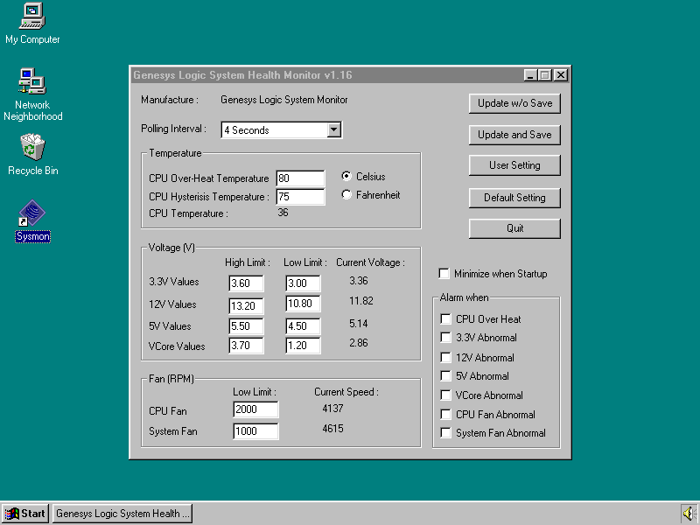

- Fan Monitoring:
There are two fan connectors, one is for CPU, the other can be a housing fan. When the fans speed is working abnormal, there will be warning (Speaker Alarm) through application software such as SM10(Small Icon for System Monitoring) to notify user. The fan monitoring function is implemented by connecting fan to 3-pin fan connector FAN1/ FAN2 and installing SM10. Referring to Page 13 (System Health Monitor).

- CPU Thermal Protection:
TM-P2BX implements special thermal protection circuits. When temperature is higher than a predefined value, there will be warning (Speaker Alarm) through application software such as SM10 (Small Icon for System Monitor) to notify user. It's automatically implemented by BIOS or SMD10, no hardware installation is needed. Referring to Page13 (System Health Monitor).
This mainboard also reserves an option to use special CPU cooling Fan. With Thermal Sensor on it. The CPU thermal sensor should be connected to J16.
- System Voltage Monitoring:
TM-P2BX is featured with a voltage monitoring system. When you turn on your system, this smart design will keep on monitoring your system working voltage. If any of voltage is over the component's standard, there will be Speaker Alarm though application software SM10 (Small Icon For System Monitor) for a warning to user. System voltage monitoring function monitors 5V, 12V, 3.3V and CPU voltage. It's automatically implemented by BIOS and SM10, no hardware installation is needed. Referring to Page 13 (System Health Monitor)

