Introduction

Specifications

System Chipset | Intel 82430 HX chipset.
CPU | One 321-pin socket 7 for Intel Pentium (P54C/CQS/ CS, P55C), AMD 5k86, K5, K6, Cyrix 6x86 (L, M2), IDT C6 processors, support 90/ 100/ 120/ 133/ 150/ 166/ 180/ 200/ 233MHz.
Memory | Expandable to 512MB (4 banks) with four 72-pin SIMM sockets onboard (Support Fast Page Mode and EDO DRAM ).
Cache | 64-bit 256/ 512KB L2 Pipeline Burst SRAM onboard or 160-pin COAST Module slot for 64-bit 256KB/ 512KB L2 SYNC. Cache Memory.
I/O | SMC 37C665, two high speed 16550 compatible serial ports, one Multi-Mode.  Parallel Port support SPP/EPP/ECP standard mode.  Two onboard PCI IDE Ports (32 bit data transfer).  Support two 360/720KB/1.2/1.44/2.88MB floppy disk devices.  One PS/2 Mouse port.
BIOS | Award System BIOS installed in socket (Flash and PnP).
Expansion slots |  | Four PCI Master Slots and four 16-bit ISA Slots.
Dimension |  | 4-layer PCB, 2/3 baby size (220mm x 280mm).
Others |  | Windows 95 Compatible.

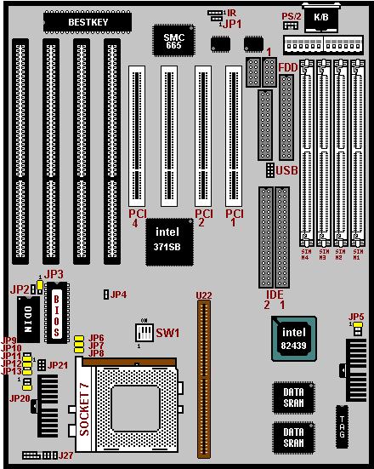
Setup Guide

Layout Diagram

CPU Voltage Settings

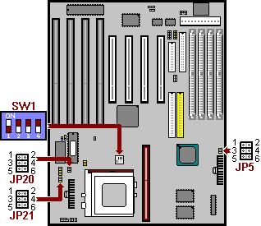
- All the voltage specifications adopted here are the averages of the working voltage suggested by the CPU makers, to make any CPU applied work with the best performance.

Pentium (P54C), AMD 5k86/ K5, Cyrix M1
 | JP5 | JP20 | JP21
3.6V
3.45V
3.3V
Pentium (P55C)
 | JP5 | JP20 | JP21
V I/O 3.3V
Vcore 2.8V

CPU Frequencies

SW1
Pentium - 75 MHz | 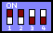
Pentium - 90 MHz | 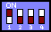
Pentium - 100 MHz | 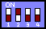
Pentium - 120 MHz | 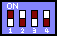
Pentium - 133 MHz | 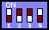
Pentium - 150 MHz
Pentium - 166 MHz | 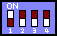
Pentium - 180 MHz | 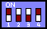
Pentium - 200 MHz | 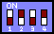
Pentium - 233 MHz

- The CPU type default setting is Intel Pentium 166MHz=66 MHz＊2.5.

DRAM, EDO RAM Installation Procedures:
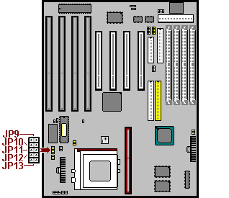

 | 256K | 512K
JP9
JP10
JP11
JP12
JP13

- SIMM Socket output voltage is 5V, expandable to 512MB.

- Support 5V Fast Page Mode/ Extended Data Out RAM.

- The BIOS DRAM default setting is 70 ns. Change the BIOS “Chipset Feature Setup” default setting to 60ns for better performance, if the chipset is marked 60ns.
- Change nothing if EDO RAM is used. BIOS automatically detects the RAM type.

- With 586 CPUs, two FPM/EDO RAM Modules are required on SIMM sockets to compose a bank for the system to start.

- MEMO for Installing System:
⊕ Concerning memory setup, you can find how to from “Chipset Feature Setup” under BIOS setup. However, to avoid system unstable or system hang, user without engineering background is not suggested to change BIOS set up.
⊕ If system boot failure, please clean SIMM socket (with clean oil) or polish Gold-Finger of DRAM with soft eraser, and try again.

Other Jumper Settings

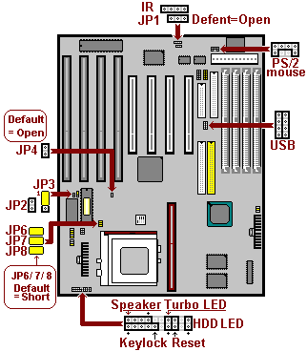
- Speaker:
Connect to the system’s speaker for beeping.
- Keylock:
Keyboard lock switch and Power LED connector.
- Reset:
Short to restart system.
- HDD LED:
LED ON when onboard PCI IDE hard disk activates.
- JP2: Clear CMOS
Turn off the system and short pins (JP2) to clear CMOS. Then open pins before turning it on.

JP2
Open | Normal operation (Default).
Short | for clearing CMOS Data.

- JP3: Flash BIOS voltage select

JP3
1-2 Short | For 5V Flash BIOS
2-3 Short | For 12V Flash BIOS

