CHAPTER 10

SCHEDULER

Contents:
- Overview
- Add a New Follow-up Item
- Modify a Follow-up Item
- Delete a Completed Follow-up Item
- Print SnapShot Report

Overview
There are going to be times when you will not be able to resolve an issue immediately. You may have to investigate the problem, consult another expert, or even set an appointment with an outside contractor. In each of these cases, you need to get back to your customer so he/she will know what the status of the issue is, and what is being done to resolve it.
The built in Scheduler can be used to post reminders for an organization or an individual. Use the calendar to set the follow-up date and time. Then, add notes so you know exactly what each call or follow-up item is about. The Scheduler keeps track of all of your follow-up items until they are complete.
Click the Scheduler  icon in the toolbar to open the module.

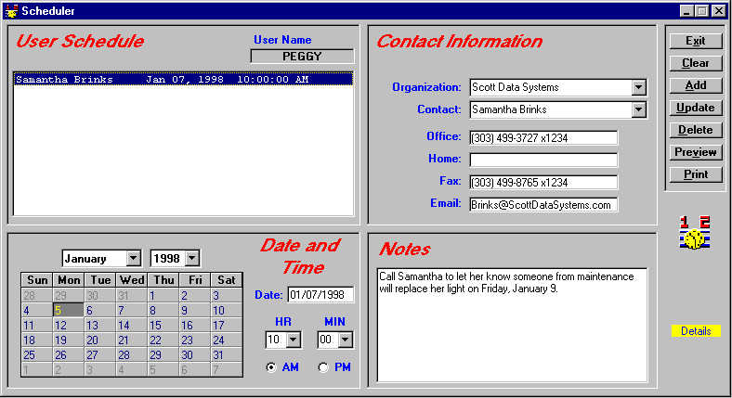
Use the calendar to set the follow-up date and time.
Your follow-up items are listed here.
Add notes to remind you of what the follow-up call or item is about.

Scheduler Module
NOTE: The green boxes around the Organization and Contact fields indicate that these are mandatory fields and must be filled in for each follow-up item. You can add a generic organization such as “individual” or “none” if the contact is not associated with an organization.

 Steps to . . .

Add a New Follow-up Item
- Select the organization name from the Organization drop down list, or click the Organization label to select from the PickList. SDS HelpDesk automatically searches for the contacts at that organization and displays the first one. If you need a different contact, select the name from the Contact drop down list.
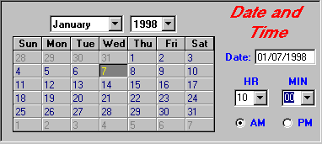
- Use the calendar section of Scheduler to set the follow-up date and time. When you open Scheduler, the current date is highlighted in the calendar.
Click one of the date buttons to select the day the follow-up item is to occur.

If needed, select the follow-up month and year from the appropriate drop down lists. Then click a date button to select the day the follow-up should occur.
- Select the follow-up hour and minute times from the appropriate drop down lists. Then select either the AM or PM radio button.
- Use the Notes field to enter any information you need for this follow-up item. It can be a reminder of what the follow-up call is about, the times a contractor is available, a note that a service contract has expired and needs to be renewed, etc.

Add a New Follow-up Item (cont’d)
- When finished, click the Add button. The contact, date, and time of the follow-up item are displayed in the large list box in the upper left corner of the Scheduler screen. Click on any of the follow-up items to see its attached notes.
- To enter another new follow-up item, click the Clear button to give you a blank screen.
NOTE: Whenever you start Scheduler, your list of follow-up items is displayed in the upper left hand box.

Modify a Follow-up Item
- Select the follow-up item you want to modify from the large list box in the upper left corner of the Scheduler screen.
- Modify the follow-up information.
- When finished, click the Update button to save your changes.

Delete a Completed Follow-up Item
- Select the follow-up item you want to delete from the large list box in the upper left corner of the Scheduler screen.
- Click the Delete button.

Print SnapShot Report
You may want to print out a list of your follow-up items. You can do this directly from the Scheduler module.
- Click the Preview button to see the report before it is printed.
- Click the Print button to get a SnapShot Report of your follow-up items.

