CHAPTER 3

GETTING TO KNOW SDS HELPDESK

Contents:
- Overview
- Setup Wizard
- Work Flow Wizard
- Getting to Know the SDS HelpDesk Window
- Selecting Items from a PickList
- Mandatory Fields

Overview
Any time you begin to learn a new program, it is hard to know just where to start. If you are the system administrator, certain items need to be set up before others begin to use the program. If you are a support professional, you want to know which modules to implement first so you can be the most affective for your customers.
There are many approaches you can take to initially set up SDS HelpDesk. Much of the information can be added “on-the-fly.” This means you can start using the program, then add new information when you need it directly from the screen where you are working. However, many times it is more efficient, and improves the accuracy of data entry, to preload the most commonly used information such as contacts, organizations, issue categories and locations. The question becomes -- What should be done when, and what information should be preloaded?
This chapter and Chapter 4: Implementation Checklist will help you answer the above question. Once you logon to SDS HelpDesk, two screens will open. They are the Setup Wizard and the Work Flow Wizard. These screens will help you set up your own help desk database.
Many procedures are similar throughout SDS HelpDesk. Once you learn the basic procedures, you can use them in any of the modules. This helps to shorten your learning curve and get you up and running quickly. This chapter also provides basic procedure information.

Setup Wizard
The Setup Wizard can be used to help the system administrator configure SDS HelpDesk. Until you check the “Hide this Screen” box, Setup Wizard opens after you logon to SDS HelpDesk. To launch Setup Wizard after the “Hide this Screen” box is checked, click the Help menu. Select the Show Setup Wizard option.

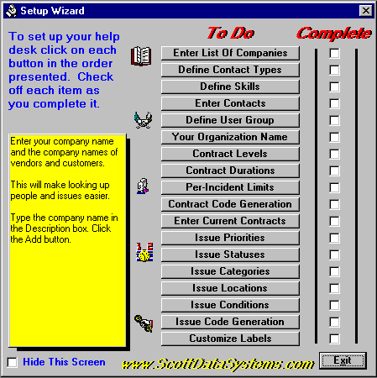
Setup Wizard (cont’d)
As you complete each item, check the appropriate box. This helps you keep track of where you are in the setup process.
This box provides tips as you move your mouse over the buttons.
Check this box when you are finished with all of the items.
As you move your mouse cursor over each button, a description or tip is displayed in the large box on the left.
- Click on each button in the order presented. This launches the appropriate dialog box or module. Detailed instructions for each of these setup items can be found in Chapter 5: Setting Up HelpDesk.
- As you complete each item in the Setup Wizard, check the box next to it. This will help you keep track of where you are in the setup process.
- When you have finished with all of the setup items, check the “Hide this Section” box. When this box is checked Setup Wizard does not open automatically after you logon to SDS HelpDesk.

Work Flow Wizard
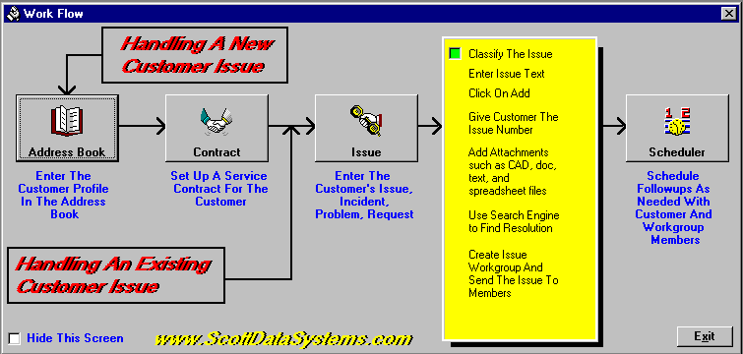
The Work Flow Wizard displays how information flows through SDS HelpDesk. To launch the Work Flow Wizard, click the Help menu. Select the Show Work Flow Wizard option.
Check this box to hide the screen.

SDS HelpDesk uses the contact as the starting point for all other information. Click each button to open the module as you talk with your customers. Detailed instructions for each module can be found in the appropriate chapter or you can use Help or context-sensitive help. The following describes the recommended process for entering new information.

Work Flow Phase 1: Enter Contact Information into Address Book
It is recommended that you start with Address Book whenever a new customer calls. While it is not mandatory that you fill in all of the information in Address Book, you do need to enter the contact name and the organization if there is one. It is also recommended that you enter a phone number so that you can contact the customer again if necessary. The name and organization are used throughout all of the other modules. Once you have entered the contact information into Address Book, use the Work Flow Wizard to go into Phase 2: Enter Service Contract Information. If your organization does not use service contracts, you can skip Phase 2 and go directly into Phase 3: Enter Issue Information.

Work Flow Wizard (cont’d)

Work Flow Phase 2: Enter Service Contract Information
Once you have entered the customer information into Address Book, you can enter the appropriate service contract information. After you have set up a valid service contract, you can move to Phase 3: Enter Issue Information. If your organization does not use service contracts, you can skip Phase 2 and go directly to Phase 3.

Work Flow Phase 3: Enter Issue Information
Enter the appropriate issue information for the customer. While it is not mandatory that you fill in all of the information in Issue Manager, you do need to specify the organization and the issue category/subcategory. It is recommended that you also specify the issue location information. Doing this greatly enhances your search capabilities. In some cases you may find that you cannot resolve the issue immediately and need to follow up later with the customer. When this is the case, proceed to Phase 4: Set up Follow-up Items.

Work Flow Phase 4: Set up Follow-up Items
Phase 4 is only needed when you find that you cannot resolve an issue immediately and you need to investigate the issue, communicate with work group members, and follow up with a customer.

Getting to Know the SDS HelpDesk Window
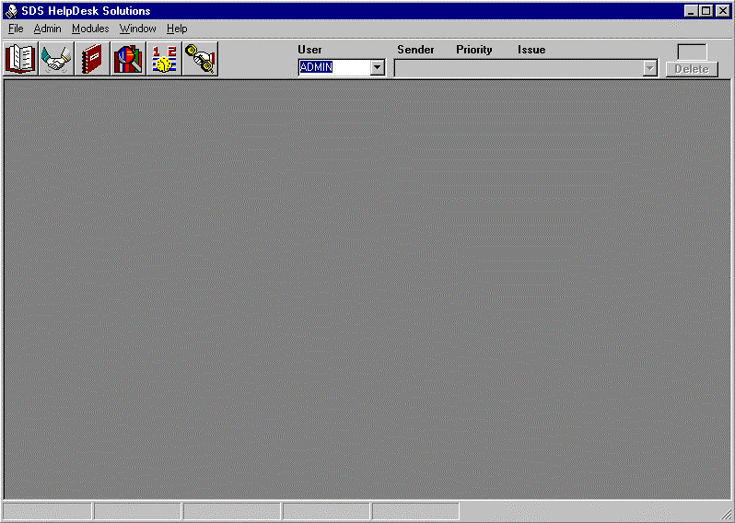The main window is displayed when you start SDS HelpDesk. The major elements found in this window are the Main Menu, the Toolbar, and the Status Bar. Each element is described below.
Status Bar
Toolbar
Main SDS HelpDesk Window

The Main Menu
Each item on the menu bar opens a drop down list of commands. The menu bar items include File, Admin, Modules, Window, and Help. The commands let you perform specific operations, open dialog boxes to enter needed information, or select the SDS HelpDesk database.
- File Menu – The File Menu includes commands to enter or change your SDS License Code, connect to the SDS HelpDesk database, refresh the database information, or exit the program.

The Main Menu (cont’d)
- Admin Menu – This menu is available only to users with system administrator permissions. It includes commands to view user logons, add users, enter the organization name, change the path to the Help and reports files, set service contract and issue code formats, and set issue location labels.
- Modules Menu – Each of the modules can be launched from this menu. It also includes commands to change a password, prompt when adding information on-the-fly, and change workstation fonts.
- Window Menu – Use this menu to set how individual windows are displayed on the screen. With SDS HelpDesk, you can open multiple copies of the same module.
- Help Menu –The Help menu is used to activate the on-line help file, launch the Setup or Work Flow Wizards, find out how to register SDS HelpDesk, or find out about this version of SDS HelpDesk.

The Toolbar
The toolbar provides shortcuts to HelpDesk modules and displays a list of open issues that have been set to you for review.
1 2 3 4 5 6 7 8 9
1 Address Book
2 Service Contract Manager
3 Reports Manager
4 Lookup Tables
5 Scheduler
6 Issue Manager
7 User Name drop down list
8 Drop down list of open issues that have been set to you for review
9 The box alerts you of your new or not yet reviewed issues

Selecting Items from a PickList
PickLists are used throughout SDS HelpDesk to enter repetitive data (e.g., organizations, categories, subcategories, issue locations, priorities, statuses, contract limits and durations, conditions, skills, and contact types. The information that is entered in Lookup Tables is displayed in the various PickLists.
- Open a module. When you move your mouse cursor over any of the labels listed above, you will see a tool tip.
- Click the label to bring up the appropriate PickList.
- The skills, status, priority, contact type, contract limit, contract level, and contract duration PickLists display items in a list format. Double-click any item in the PickList and it is entered for you automatically.
- The category, location, condition, and organization PickLists display items in a tree-like format. This format enables you to view the hierarchy of items. A plus (+) next to an item means that there is another level below it. Click the plus (+) to see the next level. Double-click the lowest level item and it and all of the levels above it are entered for you automatically.

Mandatory Fields
Some fields are mandatory and need to be entered. A green box surrounds the mandatory fields in each module. The Add button does not become active until the mandatory fields are filled in.

