CHAPTER 5

SETTING UP SDS HELPDESK

Contents:
- Overview
- Connect to the Database
- Enter the Organization Name into the System
- Set or Reset Report Files Location
- Set or Reset Help File Location
- Users List, Permissions, and Initial Passwords
- View Concurrently Logged on Users
- Format Service Contract Codes
- Format Issue Codes
- Define and Customize Issue Location Labels
- Change User Password
- Customize Workstation Fonts
- Enable or Disable Prompt Message for Adding Data On-the-fly

Overview
This chapter was written to help the system administrator configure SDS HelpDesk. It includes step-by-step instructions for those items that need to be set up before others begin using the program. These are the items that are included in Setup Wizard shown in Chapter 3 and in Stage 1 of the Implementation Checklist shown in Chapter 4.
Three setup items are also covered in this chapter for individual users. They include changing your password, customizing workstation fonts, and enabling or disabling a prompt message that is given when adding data on-the-fly. These items can be set up at any time.

Connect to the Database
SDS HelpDesk needs to know where the database is located. The database is where all of the information you enter into the program is stored. This connection is taken care of for you automatically if SDS HelpDesk is installed on a single computer. In a multi-user environment, the database file (HelpDesk.mdb) usually is moved to the network server. When this happens, you need to change the path to the new location.
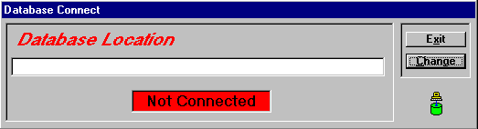
Click the File menu. Select the Connect option to open the Database Connect dialog box.
Click this button to set or reset the path to the database.

Database Connect Dialog Box
This box turns green and displays Connected when the new path is set.

Connect to the Database (cont’d)

Connect to the Database If Installed Only on One Computer
If you install SDS HelpDesk only on the computer you are using, the installation program makes the database connection for you. The steps in the next section can be used if you want to switch to the Demo database, or if you want to set up multiple databases with different names and switch between them. This is useful if you want to set up separate databases for different uses in your organization (e.g., internal MIS, product support, facilities). It is also useful if you want to safeguard the original blank database and experiment with another one.

Set Up Connection if Database is Moved to a Network Server
If you move the HelpDesk.mdb database to a network server, you will need to reset the path to the new location. These same steps can be followed if you want to switch to the Demo database, or you want to set up multiple databases with different names and you want to switch between them.
- Select the File, Connect menu to open the Database Connect dialog box. If no previous path has been set, the box is red and displays Not Connected.
- Click the Change button. This launches the Open dialog box. Use the Look In drop down list to locate the database. The default location is C:\Program Files\SDS HelpDesk Solutions\Database. Select it, then click the Open button. This takes you back to the Database Connect dialog box. The complete path to the database is displayed in the top box. The connect box turns green and displays Connected.

Enter the Organization Name into the System
You will want to enter the name of your organization into the system as part of the setup process. This is the name that can be used as part of your issue code or contract code formats. It is also used when you set up users.
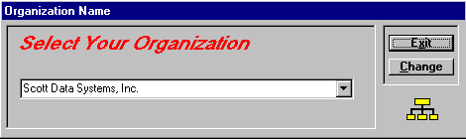
- Click the Admin menu. Select the Organization Name option to open the following dialog box.
Click this button to add or change your organization name.
- Type the name of your organization in the box.
- Click the Change button to save the organization name.

Set or Reset Report Files Location
SDS HelpDesk needs to know where the report files are located. This information is automatically entered for you if SDS HelpDesk is installed on a single computer. In a multi-user environment, sometimes the report files are moved to the network server. When this is done, you need to change the path to the new location.
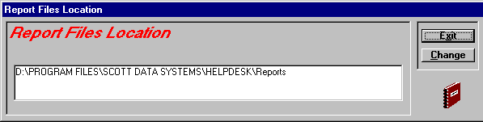
- Click the Admin menu. Select the Reports Location option to open the following dialog box.
Click this button to set or reset the path to the report files.

Set or Reset Report Files Location (cont’d)
- Click the Change button. This launches the Open dialog box. Use the Look In drop down list to locate the Reports folder. Double-click on the folder, select any of the report file names (e.g., category.rpt), and then click the Open button. This takes you back to the Report Files Location dialog box. The complete path is displayed in the box.
- Click the Exit button.

Set or Reset Help File Location
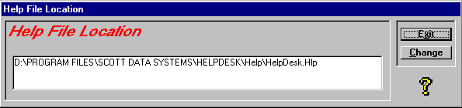
- Click the Admin menu. Select the Help File Location option to open the following dialog box.
Click this button to set or reset the path to the Help file.
- Click the Change button. This launches the Open dialog box. Use the Look In drop down list to locate the Help folder. The default path is C:\Program Files\SDS HelpDesk Solutions\Help. Double-click on the folder, select the file (HelpDesk.hlp), and then click the Open button. This takes you back to the Help File Location dialog box. The complete path is displayed in the box.
- Click the Exit button.

Users Lists, Permissions, and Initial Passwords
Anyone who needs to be able to access SDS HelpDesk, must be entered into the system as a contact and as a user by the system administrator. Use the User Manager dialog box to add authorized users, to allow certain users to modify key information, and to set initial user passwords. The system administrator can add new users at any time. The number of users who can access SDS HelpDesk concurrently is dependent upon the number of licenses you purchase.
Click the Admin menu. Select the Users option to launch the User Manager dialog box.

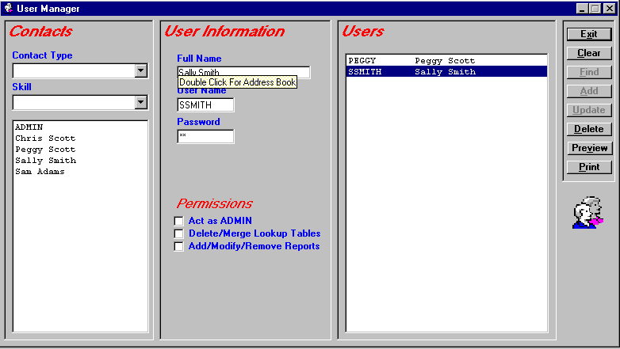
User Manager Dialog Box
This box displays the contact list. Use the Contact Type and/or Skill drop down lists as filters.
The contacts who are authorized to use SDS HelpDesk are listed here.
Right-click the Full Name label to open Address Book.

 Steps to . . .

Add a New User
- Before users can logon to SDS HelpDesk, they must be added to the Address Book via the administrator’s Users screen. Click the Admin menu on the header bar. Select the Users option. Right-click the Full Name title to open Address Book. The only information you need to enter now to set up these contacts as users are their name, organization, and contact type.
- Enter the user’s full name in the Address Book Contact box.
- Select your organization name from the drop down list, or click the label to select from the PickList.
- Select Employee from the Contact Type drop down list.
- Click the Add button to save the contact to the database. If you discover an error after clicking the Add button, select the information you need to correct, make your modifications, and then click the Update button.
NOTE: If you start with just these two mandatory pieces of information, you quickly can add all of your potential users as contacts.
- To add another user, select the current contact’s full name. Type in the name of the next user contact. Click the Add button. Repeat this process until all of your potential users are added.
- When you have finished adding the contacts that you want to designate as users, close or minimize the Address Book module. The User Manager screen should be visible. The contacts you just added are listed in the large Contacts box.
- Select the name of the person you want to designate as a user. The name is displayed in the Full Name box. Type a user name for this person in the User Name box. A User name must be unique. It can be any combination of alphanumeric characters, and is the name that is used when the user logs on. The maximum length for a user name is ten characters.

Add a New User (cont’d)
- Enter an initial password for the user. It is important to note that passwords are case sensitive. Be sure to let the user know what his/her initial password is. Keep a list of user passwords in a secure place.
- If applicable to this user, check the appropriate boxes in the Permissions section. If checked, the user will be able to carry out the function listed.
- Click the Add button to save the information. You will see the user’s full name and user name in the large right-hand box. Repeat this process for each contact you want to designate as a user of SDS HelpDesk.

Set Initial User Name
- Select the person from the User List.
- Type a user name for this person in the User Name box. A User Name must be unique. It can be any combination of alphanumeric characters, and is the name that is used when the user logs on. The maximum length for a user name is ten characters.
- Click the Update button to save your new information.

Modify User Information
- Select the person from the User List whose information you want to change.
- Make your modifications. Click the Update button to save your changes.

Delete a User
- Select the person you want to delete from the User List.
- Click the Delete button. The user will be unable to logon to SDS HelpDesk.

Add Initial User Passwords
- Select the person from the User List.
- Enter an initial password in the Password box.
- When finished, click the Update button to save your changes.

Set User Permissions
- Select the person from the User List.
- If applicable to this user, check the appropriate boxes in the Permissions section. If checked, the user is able to carry out the function listed.
- When finished, click the Update button to save your changes.

Find a User
You can use the search engine to find all users who are a specific contact type, such as employee. You can also search for users who have a specific skill (e.g., technical support, plumber, programmer, engineer).
- Select the Contact Type or Skill from the appropriate drop down list.
- Click the Find button. The filtered list displays below the drop down boxes.

Print or Preview a SnapShot Report
SnapShot reports are used when you want a printout of information for a currently selected record. In the User Manager screen, the SnapShot report gives you a list of users, user names, and permissions. The Hide column indicates which users have been deleted, but have issues or other information attached to them. They cannot logon to the system, but the information is retained for historical purposes.
- Select a person from the User List.
- Click the Preview button to see the report before it is printed.
- Click the Print button for a hard copy of the report.

View Concurrently Logged on Users
The number of licenses you purchase determines the number of users who can be logged on concurrently to SDS HelpDesk. This means you can set up any number of users, but only a certain number can use the program at the same time. The system administrator may need to know which users are logged on to the program. This is important if you have more users than concurrent licenses and need to trade off users.
Click the Admin menu. Select the Logons option to launch the User Logons dialog box.
Click this button to log a user off the system.

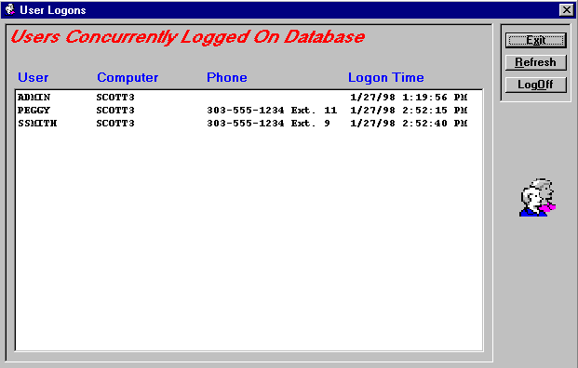
Users Logons Dialog Box

The dialog box shows which users are logged on, the computer they logged on from, their phone number, and the date and time they logged on.
- To logoff a user, select them from the list.
- Click the LogOff button. There is a one-minute timeout before the logoff takes effect.
NOTE: Be sure to notify users before logging them off the system so they have time to finish what they are doing.
Use the Refresh button to update the list of concurrently logged on users.

Format Contract Codes
SDS HelpDesk lets you customize your service contract codes/numbers. Contract codes can include fixed text, the date/time, or portions of your company name. If you already have service contracts, you can continue to use the same format.
Click the Admin menu. Select the Contract Code Assignment option to launch the Customize Contracts dialog box.
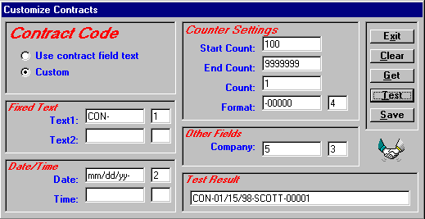
Click this button to see the current format, if there is one. This is helpful if you want to use the format as a template.
Use the small boxes to set where the option appears in the code. Example, a 1 puts the option first, a 2 second.

Customize Contracts Dialog Box

Customize Contracts Dialog Box

Steps to . . .

Set Contract Code Options
You have a lot of flexibility in how you want to set up your service contract codes. They can be a simple incrementing number, or something more complex that includes fixed text, the date/time, and an incrementing number. If you already have a format for service contract codes, you can continue using it. The important thing is that each contract code must be unique.

Set Contract Code Options (cont’d)
- There are two radio buttons to choose from. If you already have service contracts, you can choose one option during the initial data entry phase, and then switch to the Custom option for new contracts.
- Select “Use contract field text” to let users type a contract code directly into the Contract field. This is useful during the initial data entry phase for currently existing contracts, or if you have a special format that you want to continue using. If you select this radio button, you do not need to do anything else. Click the Save button.
- Select “Custom” to set up a new format. Proceed to step 2.
- You may want to include fixed text in your contract code to make it distinct from an issue code. For example, you can start each contract code with “CON.” Type the fixed text in the Text1 box. Use Text2 to add additional fixed text. Hyphens can be included before or after the text.
- The current date/time can be included as part of the code. This may be helpful if a company has multiple contracts. Type the format in the Date box (e.g., mm/dd/yy) and the format in the Time box (e.g., hh:mm:ss).
- Each contract code must be unique. Use the Counter Settings to format the incrementing number. Enter the starting number in the Start Count box.
- Enter the highest number you think you will need in the End Count box. The maximum is 99999999999.
- Use the Count box to set how the number should increment. Enter a 1 to increment the number one unit at a time, a 2 to increment the number two units at a time, etc.
- Using the number “0” in the Format box, indicate the number of digits you want. For example, enter 0000 if you want a four-digit incrementing number. If not all of the digits are used, the number shows leading zeros.

Set Contract Code Options (cont’d)
- You can include a portion of your company name in the contract code. Enter the number of letters, including spaces, that you want to include in the Company box. For example, to include “Scott Data” in all contract numbers, enter the number 10 in the Company box. The number of letters you can include is limited by the other options you choose. The maximum size of a contract code is 30 characters, including spaces, hyphens etc.
- Use the small boxes to set the order that the options appear in the contract code. For example, a 1 puts the option first, a 2 second, etc.
- Click the Test button to see how your contract code looks. The code is displayed in the Test Results box. To try another format, click the Clear button to get a blank screen.
- When you are satisfied with the format, click the Save button.

Format Fixed Text
You may want to include fixed text in your contract code to make it distinct from an issue code. For example, you can start each contract code with “CON.”
- Type the fixed text in the Text1 box. Use Text2 to add additional fixed text. Hyphens can be included before or after the text.
- Use the small box to set where the fixed text option appears in the code. For example, if you want to start each contract code with CON, enter a 1 in the small box next to the text.
- Each contract code must be unique. Use the Counter Settings to format the incrementing number (see Format Counter Settings for details).
- Click the Test button to see a sample of your format. If OK, click Save.

Format Date/Time
The current date and time can be included as part of the contract code. This may be helpful if an organization has multiple contracts.
- Type the format you want to use in the Date box (e.g., mm/dd/yy), and the Time box (e.g., hh:mm:ss).
- Use the small box to set where the date option appears in the code. For example, if you want to start each contract code with fixed text and then the date, enter a 2 in the small box next to the Date.
- Each contract code must be unique. Use the Counter Settings to format the incrementing number (see Format Counter Settings for details).
- Click the Test button to see a sample of your format. If OK, click Save.

Format Counter Settings
Each contract code must be unique. Use the Counter Settings to format the incrementing number.
- Enter the starting number in the Start Count box.
- Enter the highest number you think you will need in the End Count box. The maximum is 999999999.
- Use the Count box to set how the number should increment. Enter a 1 to increment the number one unit at a time, a 2 to increment the number two units at a time, etc.
- Using the number “0” in the Format box, set the number of digits you want. For example, enter 0000 for a four-digit incrementing number. If not all of the digits are used, the number shows leading zeros.
- Use the small box to set where the counter option appears in the code. For example, if each contract code starts with fixed text, then the date, and then the incrementing number, enter a 3 in the small box next to Format.
- Click the Test button to see a sample of your format. If OK, click Save.

Format Other Fields
You can include all or a portion of your company name in the contract code.
- In the Company box, enter the number of letters, including spaces, you want to include. For example, to include “Scott Data” in all contract codes, enter the number 10 in the Company box. The number of letters you can include is limited by the other options you choose. The maximum size of a contract code is 30 characters, including spaces, hyphens etc.
- Use the small box to set where the Company option appears in the number. For example, if each contract code starts with fixed text, then the company, and then the incrementing number, enter a 2 in the small box.
- Each contract code must be unique. Use the Counter Settings to format the incrementing number (see Format Counter Settings for details).
- Click the Test button to see a sample of your format. If OK, click Save.

Set Code Order
The small boxes next to the options are used to set the order the options appear in the contract code. For example, if you want fixed text to appear first, enter a 1 in the small box next to the text. If you want the incrementing number to appear next, enter a 2 in the small box next to Format. Enter an order number for each of the options you want to include in the contract code.

Test Sample Contract Code
You may want to see how the contract code will look before you save the format.
- Click the Test button to see a sample. The code is displayed in the Test Result box.
- When you are satisfied with the format, click the Save button.

Contract Get Button
Click the Get button to see the current contract code format if there is one. This is helpful if you want to use the format as a template.

Format Issue Codes
You can customize your issue codes/numbers to fit the needs of your company. Issue codes can include fixed text, the date/time, or a portion of your company name. If you already have issue numbers, you can continue to use the same format.
Click the Admin menu. Select the Issue Code Assignment option to launch the Customize Issues dialog box.
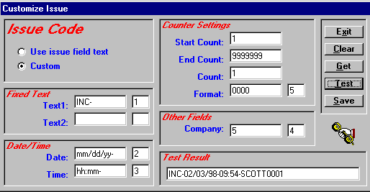
Click this button to see the current format, if there is one. This is helpful if you want to use the format as a template
Use the small boxes to set where the option appears in the code. Example, a 1 puts the option first, a 2 second.

Customize Issue Dialog Box

Steps to . . .

Set Issue Code Options
Issue codes can be simple incrementing numbers or something more complex depending on your needs. The codes can include fixed text, the date/time, and an incrementing number. If you already have a format for issue codes, you can continue using it.
- There are two radio buttons to choose from. If you already have issue codes, you can choose one option during the initial data entry phase, and then switch to the Custom option for new issues.

Set Issue Code Options (cont’d)
- Select “Use issue field text” to let users type an issue code directly into the Number field. This is useful during the initial data entry phase for currently existing issues, or if you have a special format that you want to continue using. If you select this radio button, you do not need to do anything else. Click the Save button.
- Select “Custom” to set up a new format. Proceed to step 2.
- You may want to include fixed text in your issue code to make it distinct from a service contract code. For example, you can start each issue code with “ISSUE.” Type the fixed text in the Text1 box. Use Text2 to add additional fixed text. Hyphens can be included before or after the text.
- The current date/time can be included as part of the issue code. These may be helpful if a customer calls you frequently. Type the format in the Date box (e.g., mm/dd/yy), and the format in the Time box (e.g., hh:mm:ss).
- Each issue code must be unique. Use the Counter Settings to format the incrementing number. Enter the starting number in the Start Count box.
- Enter the highest number you think you will need in the End Count box. The maximum is 999999999.
- Use the Count box to set how the number should increment. Enter a 1 to increment the number one unit at a time, a 2 to increment the number two units at a time, etc.
- Using the number “0 in the Format box, indicate the number of digits you want. For example, enter 00000 if you want a five-digit incrementing number. If not all of the digits are used, the number shows leading zeros.
- You can include all or a portion of your company name in the issue code. Enter the number of letters you want to include, including spaces, in the Company box. For example, to include “Scott Data” in all issue numbers, enter the number 10. The number of letters you can include is limited by the other options you choose. The maximum size of an issue code is 30 characters, including spaces, hyphens etc.

Set Issue Code Options (cont’d)
- Use the small boxes to set the order the options appear in the issue number. For example, a 1 puts the option first, a 2 second, etc.
- Click the Test button to see how your issue code looks. The code is displayed in the Test Results box. To try another format, click the Clear button to get a blank screen.
- When you are satisfied with the format, click the Save button.

Format Fixed Text
You may want to include fixed text in your issue code to make it distinct from a service contract code. For example, you can start each issue code with “ISSUE.”
- Type the fixed text in the Text1 box. Use Text2 to add additional fixed text. Hyphens can be included before or after the text.
- Use the small box to set where the fixed text option appears in the code. For example, if you want to start each issue code with ISSUE, enter a 1 in the small box next to the text.
- Each issue code must be unique. Use the Counter Settings to format the incrementing number (see Format Counter Settings for details).
- Click the Test button to see a sample of your format. If OK, click Save.

Format Date/Time
The current date and time can be included as part of the issue code. This may be helpful if a customer calls frequently.
- Type the format you want to use in the Date box (e.g., mm/dd/yy), and the Time box (e.g., hh:mm:ss).
- Use the small boxes to set where the date/time options appear in the code. For example, if you want to start each issue number with fixed text and then the date, enter a 2 in the small box next to the Date.
- Each issue code must be unique. Use the Counter Settings to format the incrementing number (see Format Counter Settings for details).
- Click the Test button to see a sample of your format. If OK, click Save.

Format Counter Settings
Each issue code must be unique. Use the Counter Settings to format the incrementing number.
- Enter the starting number in the Start Count box.
- Enter the highest number you think you will need in the End Count box. The maximum is 999999999.
- Use the Count box to set how the number should increment. Enter a 1 to increment the number one unit at a time, a 2 to increment the number two units at a time, etc.
- Using the number “0” in the Format box, indicate the number of digits you want. For example, if you want the incrementing number to be four digits, enter 0000 in the Format box. If not all of the digits are used, the number shows leading zeros.
- Use the small box to set where the counter option appears in the code. For example, if each issue number starts with fixed text, then the date, and then the incrementing number, enter a 3 in the small box next to Format.
- Click the Test button to see a sample of your format. If OK, click Save.

Format Other Fields
You can include all or a portion of your company name in the issue code.
- In the Company box, enter the number of letters, including spaces, you want to include. For example, to include “Scott Data” in all issue codes, enter the number 10 in the Company box. The number of letters you can include is limited by the other options you choose. The maximum size of an issue code is 30 characters, including spaces, hyphens etc.
- Use the small box to set where the Company option appears in the code. For example, if each issue code starts with fixed text, then the company, and then the incrementing number, enter a 2 in the small box.
- Each issue code must be unique. Use the Counter Settings to format the incrementing number (see Format Counter Settings for details).
- Click the Test button to see a sample of your format. If OK, click Save.

Set Code Order
The small boxes next to the options are used to set the order the options appear in the issue code. For example, if you want fixed text to appear first, enter a 1 in the small box next to the text. If you want the incrementing number to appear next, enter a 2 in the small box next to Format. Enter an order number for each of the options you want to include in the issue code.

Test Sample Issue Code
You may want to see how the issue code will look before you save the format.
- Click the Test button to see a sample. The code is displayed in the Test Result box.
- When you are satisfied with the format, click the Save button.

Issue Get Button
Click the Get button to see the current issue number format if there is one. This is helpful if you want to use the format as a template.

Define and Customize Issue Location Labels
The Location Lookup Table is used to specify where an issue occurs. You can define and change the labels used in this table for up to four different levels. As you go down each level, the location category should get more precise. SDS HelpDesk lets you be as general or as specific as you want. Just define your location labels to be the most useful for your situation. Once these labels are defined and entered into the system, they appear in each user’s Issue module.
EXAMPLE: If you develop a product, the highest level (Location 1) might be Product Name. The next level (Location 2) could be Model Number. The third level might be Serial Number, and the fourth level could be Part (e.g., motor, screen, etc.).
Click the Admin menu. Select the Labels option to launch the HelpDesk Customization dialog box.

Define and Customize Issue Location Labels
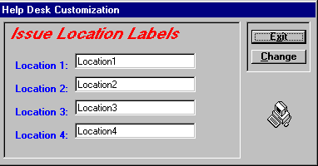
Type a new label name in each box. As you go down each level, the location category should get more precise.

Help Desk Customization Dialog Box

Once you define your issue location levels, you need to modify the default labels. These labels are used in Issue Manager and are the same for each user.
- Type a new location label in as many levels as you need. As you go down each level, the location category should be more precise. Any location label you don’t customize will retain the default label.
- Click the Change button to save the new labels. You can repeat these steps if you need to modify or add a label.

Change User Password
The system administrator should give you an initial password to get into SDS HelpDesk. You can change your password at any time.
Click the Modules menu. Select the Change Password option to launch the Change Password dialog box.
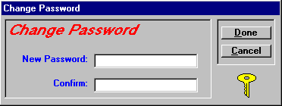
Retype your NEW password here to be sure it is right.
Type your NEW password here.

Change User Password (cont’d)
- Enter your new password.
- Then retype it in the Confirm box to be sure you entered it correctly.
- Click the Change button to save your new password.
NOTE: Passwords are case sensitive. Be sure to type your New Password in carefully and again, when you confirm it. Make sure you record your password in a secure place in case you forget it.

Customize Workstation Fonts
Each user can customize the fonts used in SDS HelpDesk for labels, groups, entry boxes, and buttons. These customizations occur only for your screens. They do not impact other users.
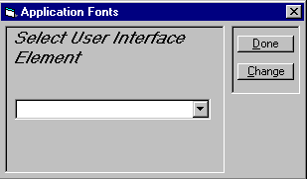
- Click the Modules menu. Select the Fonts option to launch the Application Fonts dialog box.
- Click the drop down arrow to select an item from the element list.
- Click the Change button. The Font dialog box opens. You can change the font, style, size, and/or color. Click the OK button.
- Repeat the process for each element you want to change. When finished, click the Done button.

Prompt Before Adding New Records to the Database
With SDS HelpDesk, you can set whether you want to be prompted whenever you try to add a new item to the database on-the-fly. The default is set not to prompt you for a confirmation before adding items on-the-fly.
Click the Modules menu. Select the Prompts option to launch the Prompts dialog box.
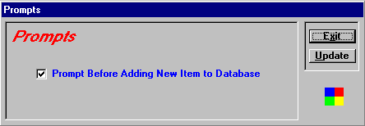
Check this box if you want to be prompted to confirm on-the-fly additions.

Prompts Dialog Box
- Check the box if you want to be prompted to confirm on-the-fly additions to the database.
- Click the Update button to save the change.
If the box is checked and you try to enter a new item on-the-fly, a prompt box like the one shown below asks you to confirm the addition.
