CHAPTER 6

LOOKUP TABLES

Contents:
- Overview
- Add a List Box Lookup Table Entry
- Add a Tree View Lookup Table Entry
- Modify a Lookup Table Entry
- Delete a Lookup Table Entry
- Print SnapShot Report
- Merge Duplicates

Overview
The Lookup Tables module is a convenient place to create lists of information such as issue categories, skills, priorities, organization names, etc. What you enter in Lookup Tables appears in the drop down lists and active label lists throughout SDS HelpDesk.
Pre-loading information into Lookup Tables helps to improve the accuracy of data entry since you can see the items that have already been added. This reduces the number of slightly different entries that sometimes get made. If variations of the same information do get entered (e.g., Scott Data Systems and Scott Data Systems, Inc.), SDS HelpDesk lets you merge the data into one record. If you don’t have time to enter data in advance, don’t worry. You can enter the information when you first need it in the other modules. This is called adding information “on-the-fly.”
One of the key features of the Lookup Table Module is its flexibility. Just choose an appropriate table, then create a list of items you want to track.
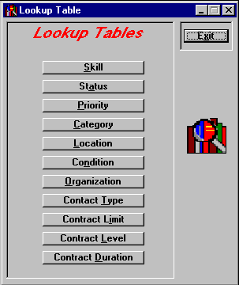
Click the Lookup Tables icon  in the toolbar to open the module.
Each button represents a different Lookup Table. Click a button to open the table.
Lookup Table Manager

Overview (cont’d)
When you click on the following Lookup Table buttons, a list box data entry screen, like the one shown blow, opens.
- Skill
- Status
- Priority
- Contact Type
Enter a new item here.
- Contract Limit
- Contract Level
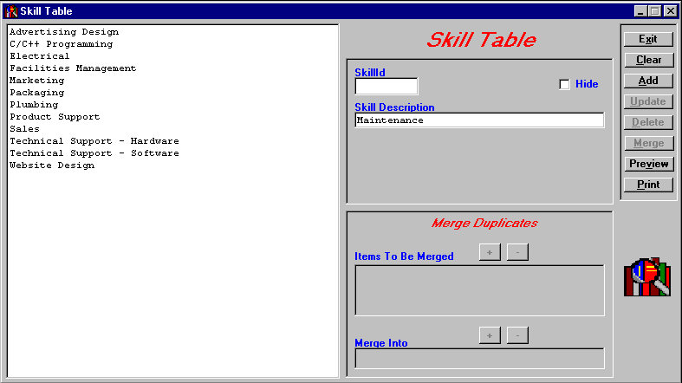
- Contract Duration
The current Lookup Table items are listed here.

List Box Lookup Table

Some Lookup Tables can have multiple levels. These levels are set up in a hierarchy with the broadest item at the top. At each lower level, the item should be more precise. The following Lookup Tables display items in a tree-like format. This format enables you to view the hierarchy of the items.
- Category
- Location
- Condition
- Organization

Overview (cont’d)
The following is an example of a tree view Lookup Table. The left-hand box displays the various levels of items. You can set up to four levels in the Location table and up to two levels in the Category, Organization, and Condition tables.
The Category Table is used to classify the general types of issues your customers may call about (e.g., product defects, how to questions, broken equipment). Set up subcategories when you want to break the category into more specific groups. For example, if you have an issue category called Broken Equipment, you can add Air Conditioner, Copy Machine, and Ceiling Fan as subcategories.
The Location Table is used to specify where an issue has occurred. Each level you add should be more specific. For example, if you develop a product, the highest level might be Product Name. The next level could be Model Number. The third level might be Product Area (e.g., motor, screen, handle), and the fourth level could be Part Number.
NOTE: If you are the system administrator and you haven’t defined and changed the issue location labels yet, see Chapter 5, Define and Customize Issue Location Labels.

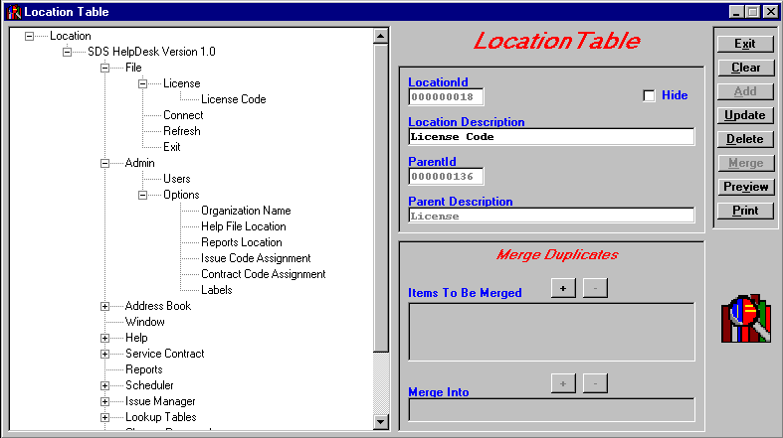
Enter a new item here.

The level directly above the item is displayed here.

Tree View Lookup Table

Overview (cont’d)
The following is a close-up view of how the sample Location Table items are displayed. In this example, the highest issue location level is SDS HelpDesk Version 1.0. The minus (-) next to it means the level has been expanded to show the levels under it.
The next level down has several items including File, Admin, Address Book, and Window. The line that runs from File to Window indicates these items are at the same level in the hierarchy. The plus (+) next to Admin and Address Book means they too have other levels below them, but have not yet been expanded. Click the (+) to display other levels.
File has been expanded to show a third level. This level also includes several items including License, Connect, Refresh, and Exit. License is the only item with another level.
License has been expanded to show the final fourth level item, License Code.

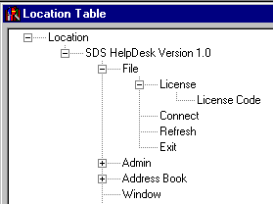
Minus (-) means all levels below are displayed.

No sign means there are no lower levels.

Plus (+) means there are other levels. Click the (+) to expand.
Click on an item to add a level below it.

 Steps to . . .

Add a List Box Lookup Table Entry
- Select the table you want from the Lookup Table main screen.
- Any previous entries to this table are displayed in the large list box. Check to see if the item you want to add already exists. If not, type the new item in the Description box.
- Click the Add button, or press ALT + A to add information quickly. The item is added to the list and highlighted.
- Click the Tab key. This returns you to the Description box and highlights the previous entry.
- While the previous entry is highlighted, type in the next item. Press
ALT + A. Repeat this process until you are finished adding new items to the Lookup Table.

Add a Tree View Lookup Table Entry
- Select the table you want from the Lookup Table main screen.
- Any previous entries to this table are displayed in a tree-like format in the large box. Check to see if the item you want to add already exists. Since It may be in a lower level, click the (+) if there, to expand to the next level.
- Click on an item to add a new level item below it (e.g., click on a category to add a subcategory to it, or click on a first level location to add a second level location to it).
- Click the Tab key. This takes you to the Description box and highlights the item. While still highlighted, enter the new item in the Description box.
- Click the Add button, or press ALT + A. The item is added to the tree.
- To add another item to this same level, click the Tab key. Enter the new item in the Description box. Press ALT + A. Repeat this process until you are finished adding new items to the Lookup Table.

Add a Tree View Lookup Table Entry (cont’d)
EXAMPLE: You want to add a new category called Broken Equipment to the Category Lookup Table. Then you want to add two subcategories to it called Air Conditioner and Copy Machine.
- Open the Category Lookup Table.
- Click Category in the big box to select it. Press the Tab key.
- Enter Broken Equipment in the Description box. Press ALT + A to add the new category to the tree. You will notice that Category is still highlighted. This enables you to add a number of new categories quickly.
- In this example, you want to add two subcategories to Broken Equipment. Select Broken Equipment in the tree to highlight it. Press the Tab key.
- Enter Air Conditioner in the Description box. Press ALT + A. Since you want to add another subcategory to Broken Equipment, press the Tab key.
- Enter Copy Machine in the Description box. Press ALT + A.

Modify a Lookup Table Entry
- Select the appropriate table from the Lookup Table main screen.
- Select the entry you want to modify. If it is a tree view type of Lookup Table, you may need to click the (+) to expand the level. Once selected, the entry is displayed in the Description box.
- Click on the Description box entry and then make your changes.
- Click the Update button to save your changes.

Delete a Lookup Table Entry
- Select the appropriate table from the Lookup Table main screen.
- Select the entry you want to delete. If this is a tree view type of Lookup Table, you may need to click the (+) to expand the level. Once selected, the entry is displayed in the Description box.
- Click the Delete button.
NOTE: You can’t delete a Lookup Table entry if it is connected to something else. For example, you can’t delete the category Broken Equipment if it has an issue. SDS HelpDesk hides the entry and it no longer is available to users. The entry does appear in the SnapShot Report, but the Hide column is marked Yes.

Print SnapShot Report
You may want to preview or print out the contents of your Lookup Tables. You can do this directly from the Lookup Table module. The Hide column in some SnapShot Reports indicates which items are no longer available to users. These are items that are connected to something else (e.g., an issue) and can’t be deleted.
- Select the table from the Lookup Table main screen.
- Click the Preview button to see the report before it is printed.
- Click the Print button for a hard copy of the report.

Merge Duplicates
If you have multiple support professionals using SDS HelpDesk, you may find slightly different entries being made for the same item. For example, one user may enter a company as Scott Data Systems. Another user may enter the same company as Scott Data Systems, Inc. Because they are not exactly the same, the program looks at them as two different companies.
Lookup Tables helps to reduce these duplicates since you can see what has been entered previously. But, if slight variations of the same information do get entered, you can merge the data into one record. This is especially important if contacts and issues have been entered under both company names.
Note: When you do a merge duplicates, all information associated with the similar names are merged into a single record.

Merge Duplicates (cont’d)
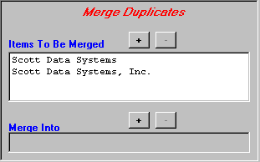
The merge duplicates function is located at the bottom of each Lookup Table screen. A sample is recreated here for your reference.
Click to add items.

Click to remove items.
Merge Duplicates Portion of Lookup Tables Screen

- Select the table from the Lookup Table main screen that contains the similar entries.
- Select the first entry you want to merge from the large Lookup Table box. If this is a tree view type of Lookup Table, you may need to click the (+) to expand the level.
- Click the Items To Be Merged button. The first entry is listed in the box. Repeat steps 2 and 3 for the next entry or entries you want to merge. Click the button to remove an item from the box.
- Select from the Lookup Table list or tree view box, the one item you want everything else merged into.
- Click the Merge Into button. The name of the item is displayed in the box. If this is not the item you want, click the button and repeat steps 4 and 5.
- Click the Lookup Table Merge button. The other similar names are deleted from the Lookup Table list or tree view box. All the information associated with these other names has been merged into the one remaining record.

